PROJECT DEVELOPMENT PHASE

Project Development-Delivery of sprint-2

User search page:

Home.html

<html>

<html lang="en">

<head>

<title>News Tracker</title>

<link rel="stylesheet" type="text/css" href="{{url_for('static',filename='newstyle.css')}}">

<link rel="stylesheet" type="text/css" href="{{url_for('static',filename='font/css/all.min.css')}}">

<link rel="stylesheet" href="https://cdnjs.cloudflare.com/ajax/libs/font-awesome/6.2.1/css/all.min.css"/>

</head>

<body>

<div class="News">

<header>

<div class="logo">

<pre style="font-size:20px ; font-family:Times New Romon; ">News Tracker

</pre>

</div>

<div class="search-box">

<i class="fa-solid fa-magnifying-glass"></i>

<input type="search" placeholder="Search">

</div>

<nav>

<ul>

<li><a href="/Home"><i class="fa-regular fa-address-card"></i> Home</a></li>

<li><a href="/Local"><i class="fa-regular fa-address-card"></i> Local</a></li>

<li><a href="/Coronavirus"><i class="fa-regular fa-address-card"></i> Coronavirus</a></li>

<li><a href="/about1" ><i class="fa fa-edit"></i>aboutus </a></li>

<li><a href="/register1" ><i class="fa fa-edit"></i> Register</a></li>

<li><a href="/login1" ><i class="fa fa-edit"></i> login</a></li>

<ul>

</nav>

</header>

</body>

</html>

newstyle.css

*{

margin:0;

padding:0;

box-sizing:border-box;

font-family:sans-serif;

}

/*header*/

header{

display:flex;

justify-content:space-between;

align-items:center;

padding:10px 18%;

border-bottom:1px solid rgba(219,219,219,1);

background-color:#42eff5 ;

}

header .logo{

height:29px;

float:left;

}

header .logo pre{

height:100%;

object-fit:contain;

}

header .search-box{

width:250px;

background-color:rgba(239,239,239,1);

padding:3px 16px;

display:flex;

align-items:center;

border-radius;30px;

}

header .search-box input{

height:30px;

border:none;

outline:none;

background-color:rgba(239,239,239,1);

padding-left:10px;

}

header nav ul{

list-style:none;

display:flex;

}

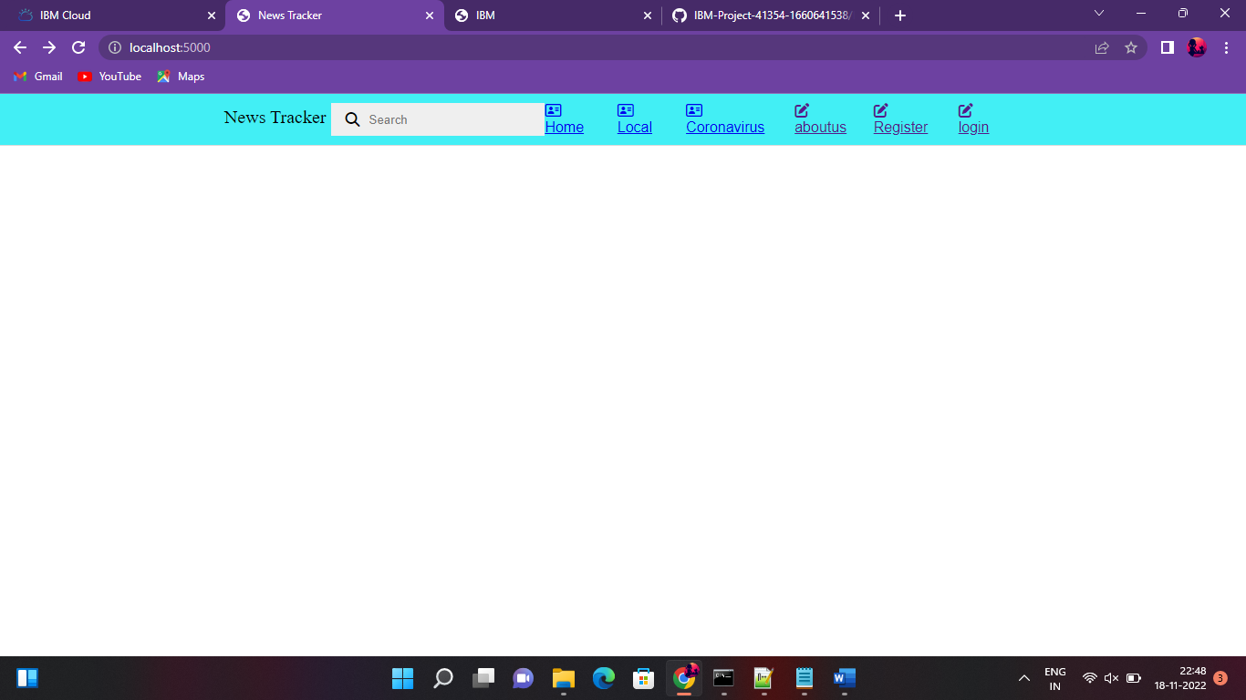

Python coding:

import os

import time

import webbrowser

import sys

os.system('clear')

print("Hi i am Like Google but a bit crazy one")

Name = input("So what should i call you: ")

print("Hi", Name, "my name is Seainte")

print("So what would you like to search for topics will be given\nGames\nYoutube\nInternet\nCoding")

Search = input("Enter your topic here: ")

#Search variable input games Done

if Search == 'Games' or Search == 'games':

os.system('clear')

print("The topics are:\nFlying\nSandbox\nRealistic")

Games_Search = input("Enter your topic here: ")

if Games_Search == 'Flying' or Games_Search == 'flying':

print("Loading...")

time.sleep(5)

webbrowser.open('https://www.geo-fs.com/geofs.php', True)

elif Games_Search == 'Sandbox' or Games_Search == 'sandbox':

print("Loading...")

time.sleep(5)

webbrowser.open('https://www.minecraft.net/en-us/', True)

elif Games_Search == 'Realistic' or Games_Search == 'realistic':

print("Loading...")

time.sleep(5)

webbrowser.open('https://mypcgames.net/gta-5-download-for-pc/', True)

else:

print("Wrong input or topic please enter the correct topic/input next time", Name)

#Search variable input youtube Done

elif Search == 'Youtube' or Search == 'youtube':

os.system('clear')

print("So the topics are:\nComedy\nGaming\nLearning\nSongs")

Youtube_Search = input("Enter your topic: ")

if Youtube_Search == 'Comedy' or Youtube_Search == 'comedy':

print("Laoding...")

time.sleep(5)

webbrowser.open('https://www.youtube.com/watch?v=J-zn8PdvZOU&t=16s&ab_channel=ashishchanchlanivines', True)

elif Youtube_Search == 'Gaming' or Youtube_Search == 'gaming':

print("Loading...")

time.sleep(5)

webbrowser.open('https://www.youtube.com/gaming', True)

elif Youtube_Search == 'Learning' or Youtube_Search == 'learning':

print("Loading...")

time.sleep('https://www.youtube.com/results?search_query=learning', True)

elif Youtube_Search == 'Songs' or Youtube_Search == 'songs':

print("Loading...")

time.sleep(5)

webbrowser.open('https://www.youtube.com/results?search_query=english+songs', True)

else:

print("Wrong topic please enter the correct topic next time", Name)

#This is for Search variable Internet input Done

elif Search == 'Internet' or Search == 'internet':

os.system('clear')

print("So the topics are:\nSearch\nLearn\nplay games online\nDownload stuff")

Internet_Search = input("Enter your topic: ")

if Internet_Search == 'Search' or Internet_Search == 'search':

print("Loading...")

time.sleep(5)

webbrowser.open('https://www.google.com/', True)

elif Internet_Search == 'learn' or Internet_Search == 'Learn':

print("Loading...")

time.sleep(5)

webbrowser.open('https://www.youtube.com/watch?v=8I7iboAG4gE&ab_channel=ADSRMusicProductionTutorials', True)

elif Internet_Search == 'Play games online' or Internet_Search == 'play games online':

print("Loading...")

time.sleep(5)

webbrowser.open('crazygames.com', True)

elif Internet_Search == 'Download stuff' or Internet_Search == 'download stuff':

print("Loading...")

time.sleep(5)

webbrowser.open('https://tlauncher.org/en/', True)

else:

print("Wrong topic please enter the correct topic next time", Name)

#This is for Search input from Search variable Done

elif Search == 'Coding' or Search == 'coding':

os.system('clear')

print("So the topics are:\nPython\nC\nC#\nJavascript")

Coding_Search = input("Enter your topic: ")

if Coding_Search == 'Python' or Coding_Search == 'python':

print("Loading...")

time.sleep(5)

webbrowser.open('https://www.programiz.com/python-programming', True)

elif Coding_Search == 'C' or Coding_Search == 'c':

print("Loading...")

time.sleep(5)

webbrowser.open('https://www.programiz.com/c-programming', True)

elif Coding_Search == 'C#' or Coding_Search == 'c#':

print("Loading...")

time.sleep(5)

webbrowser('https://www.programiz.com/csharp-programming', True)

elif Coding_Search == 'Javascript' or Coding_Search == 'javascript':

print("Loading...")

time.sleep(5)

webbrowser.open('https://www.programiz.com/javascript', True)

else:

print("Wrong topic please enter the correct topic next time", Name)